Test Plan and Scope

1. Scope and Limitation

* Scope

Testing will cover component testing of the Google Photos Application through 3 different platforms i.e., Web, Android and iOS.

The testing on these platforms will cover the installation of Google Photos on these platforms as well as testing of 9 selected unique components to determine that the code works on all the three platforms.

* Limitation and Exclusion

Functionalities of Google Photos from the 2.12.150668919 iOS and 2.11.0.150493453 android version are to be tested using test interfaces designed for each platform.

It is possible that some functionalities will be shown to be incorrect, errors of this type will be entered as a defect in the defect tracking system.

The testing is based on 3 major and unique components of Google Photos on each iOS, android and web platform, leaving out other non- critical components or components that have been covered in other platforms.

1. Test Approaches and Strategy

Following approach has been used for testing the application:

* Test Approach

The objective of the testing is to verify the correctness of the 9 selected components of Google Photos across 3 different platforms (Web, Android and iOS). The testing will focus on functionality of Assistant, search and Main menu on Android platform; Photos, Create Album, Back-up and Sync on iOS platform and Upload, Share and Albums on Web platform.

Testing will be accomplished through an organized testing process that will have repeatable tests. This process will be accomplished by use of scripts created and designed to match the requirements being developed for the Google Photos application.

Planning for the execution of test scripts for the selected components will be done in coordination with the plan for creating test cases.

Test Cases will be structured to give a full range of coverage to the converted components in both a negative and positive manner, simulating what a potentially unfamiliar user might do during use. Positive test cases will reflect that the application functions as expected and described in the Requirement Specification and Project Plan document. Negative test cases are tests that exercise the limits and boundaries outside the expected designs. The result of this testing will give us some idea as to the stability for the application and its selected components.

* Test Strategy

It includes identifying 9 unique components of Google Photos application across 3 different platforms that include Android, iOS and Web.

Functional testing will be performed on these 9 components by complete test case planning, test case creation and test case execution.

The strategy also includes performing the Test Closure activities at the end of the testing phase.

1. Entrance/Exit Criteria

* Entrance Criteria
* Scope of testing has been decided and agreed upon by each team member.
* Components to be tested on each platform have been identified
* Process of Logging defects and improvements has been identified and approved of by each team member
* All the team members have device(s) that supports at least one of the three identified platforms for testing
* Test case template has been agreed upon by each team member
* Exit Criteria
  + Test Plan completed
  + The test cases for all the listed components for each platform have been created
  + All the test cases have been executed
  + All the defects for each component have been identified and documented
  + Improvements identified if any, have been documented
  + All the expected and actual results have been captured and documented
  + Sign off from all the team members for the testing done by other team members.

1. Testing Requirements

**Web Platform:**

1. Validate that an album can be shared
   1. Validate that an album intended to be shared can be selected
   2. Validate that share button can be clicked
   3. Check if the person with whom the album is to be shared can be selected.
   4. Check if return button can be clicked
2. Validate enabling comments functionality on shared albums
   1. Open a shared album
   2. Validate that the options menu of the shared album opens.
   3. Validate that the enable comments option can be selected.
   4. Validate that another user with whom the album is shared can also comment
   5. Validate that the comments of the participants are visible to everyone with whom the album is shared.
3. Validate that album can be added
   1. Validate that a picture can be uploaded
   2. Validate that it can be saved under a new album
   3. Validate that it reflects under the albums category
4. Validate that changes to shared album are reflected to other participants
   1. Validate that a shared album can be selected
   2. Check if a picture can be added/deleted from the shared album
   3. Check if other participants can view the changes in the shared album
5. Validate that an image/video can be uploaded
   1. Validate that the upload button is working
   2. Validate that an image/video can be selected for uploading
   3. Validate that the upload is successful for stipulated format and resolution types.
6. Validate that an image can be uploaded using drag and drop technique
   1. Validate that an image can be dragged and dropped to the page
   2. Validate that the image can be dropped anywhere on the screen
   3. Validate that the upload is successful for stipulated format and resolution types.
7. Validate that a cover photo for the album can be added
   1. Validate that an album can be selected
   2. Validate that the option menu for the album can be selected
   3. Check if set album cover photo option can be selected
   4. Check if a picture can be selected from the album as the cover photo
   5. Check if the changes are reflected in the album
8. Validate that deleting all the photos from an album does not delete the album
   1. Validate that an album can be selected
   2. Validate that all the photos from the album can be deleted
   3. Validate that the album is still displayed without any photos
9. Validate adding location to an album
   1. Validate that an album can be selected
   2. Validate that edit album option can be selected
   3. Validate that add location option can be selected
   4. Validate that desired location can be entered
   5. Validate that the changes are saved
10. Validate deleting a movie

10.1 Validate that a movie to be deleted can be selected

10.2 Validate that the options menu can be selected

10.3 Validate that the delete option can be selected

10.4 Validate that the movie is deleted successfully

1. Validate getting a desktop uploader link
   1. Validate that the albums icon can be selected
   2. Validate that the movies option can be clicked
   3. Validate that the link can be clicked
   4. Validate that the back button can be selected

**Android Platform:**

1. Validate the working of suggested new creations functionality
   1. Validate that the assistant can be opened
   2. Validate that the save option at the end of suggestion can be clicked
   3. Validate that the saved changes have been applied and are reflected successfully
2. Validate the functioning of location history functionality
   1. Validate that the assistant can be opened
   2. Validate that the turn on location history option can be selected
   3. Validate that the changes are applied and the track of location history is maintained.
3. Validate the working of create new functionality
   1. Validate that the assistant is opened
   2. Validate that the create new collage option can be selected
   3. Validate that the desired photos can be selected
   4. Validate that the collage is created successfully
4. Validate the working of Activity Cards

15.1 Validate that the assistant is opened

15.2 Validate that a photo can be shared with other signed in account

15.3 Validate that signing into the other account the assistant can be opened

15.4 Validate that the New Activity card is displayed with the shared image

1. Validate that the Photo scanning functionality
   1. Validate that the hamburger icon can be selected
   2. Validate that Scan photos option can be selected
2. Validate the working of send feedback functionality
   1. Validate that the hamburger icon can be selected
   2. Validate that Send Feedback option can be selected
   3. Validate that feedback can be entered and send button can be clicked
   4. Validate that feedback is submitted
3. Validate the working of settings functionality
   1. Validate that the hamburger icon can be selected
   2. Validate that Settings option can be selected
   3. Validate that various settings can be selected from the list
   4. Validate the changes made to the settings are applied successfully
4. Validate the working of help functionality
   1. Validate that the hamburger icon can be selected
   2. Validate that help option can be selected
   3. Validate that the user is able to search for any help through the search bar
5. Validate the functioning of bin functionality
   1. Validate that the hamburger icon can be selected
   2. Validate that the bin option can be selected
   3. Validate that an item can be deleted from the bin
   4. Validate that an item can be restored from the bin
6. Validate the functioning of free up space functionality
   1. Validate that the hamburger icon can be selected
   2. Validate that the free up space option can be selected
   3. Validate that the images can be deleted from the device using free up space option
   4. Validate that the images are successfully deleted after selecting the free up space option
7. Validate the functioning of search functionality
   1. Validate that a search string can be entered in the search barto search for an image/video
   2. Validate that apt results are displayed for the search string entered based on general keyword search mechanism

**iOS Platform:**

1. Validate that the photos are backed up
   1. Validate that wifi is on
   2. Validate if wifi is not on then mobile data is turned on with the settings option to back up with mobile data is turned also turned on
   3. Validate that the new photos added to the device are backed up
2. Validate that the photos are backed up
   1. Validate that wifi is on
   2. Validate if wifi is not on then mobile data is turned on with the settings option to back up with mobile data is turned also turned on
3. Validate that the videos are backed up
   1. Validate that wifi is on
   2. Validate if wifi is not on then mobile data is turned on with the settings option to back up with mobile data is turned also turned on
   3. Validate that the new videos added to the device are backed up
4. Validate that the accurate count of photos/videos to be backed up is displayed
   1. Validate that the back-up option is on
   2. Validate that the correct count of photos is displayed while backing up
5. Validate that an album can be created
   1. Validate that 1-50 images can be selected at one time
   2. Validate that create album option can be selected
   3. Validate that an album name can be entered
   4. Validate that the images are successfully added to the album
6. Validate that a collage can be created
   1. Validate that an 2-9 images(inclusive) can be selected at one time
   2. Validate that create collage option can be selected
   3. Validate that a collage name can be entered
   4. Validate that the images are successfully added to the collage
7. Validate that a movie can be created
   1. Validate that images can be selected
   2. Validate that videos can be selected
   3. Validate that create movie option can be selected
   4. Validate that a movie s created
8. Validate that duplicate items cannot be added
   1. Validate that 2 similar photos are selected to be added
   2. Validate that add option is clicked
   3. Validate that the user is denied adding duplicate items
9. Validate that the original photo from the device can be deleted
   1. Validate that the photos under the device category are selected
   2. Validate that the delete device original from the options menu can be selected
   3. Verify if the items are deleted from the device
10. Validate that an item can be shared
    1. Validate that an item is selected to be shared
    2. Validate that the share icon is clicked
    3. Validate that the get link option is clicked
    4. Validate that the item is shared
11. Validate that an item can be deleted
    1. Validate that an item is selected to be deleted
    2. Validate that the delete icon is clicked
    3. Validate that the delete option is clicked
    4. Validate that the item is deleted
12. Validate the functioning of Layout functionality
    1. Validate that the option menu can be selected
    2. Validate that the Layout option can be selected
    3. Validate that any of the layouts can be selected

1. Test Case Template

The test case template used in this project is the one provided in TestRail. It specifies:

* Test Case ID
* Test Case Name
* Type of Test Case
* Priority (Critical/ High/ Low/ Medium)
* Estimate
* References
* Preconditions
* Steps (contains step and expected result)

A Screenshot of the test case is provided below for reference.

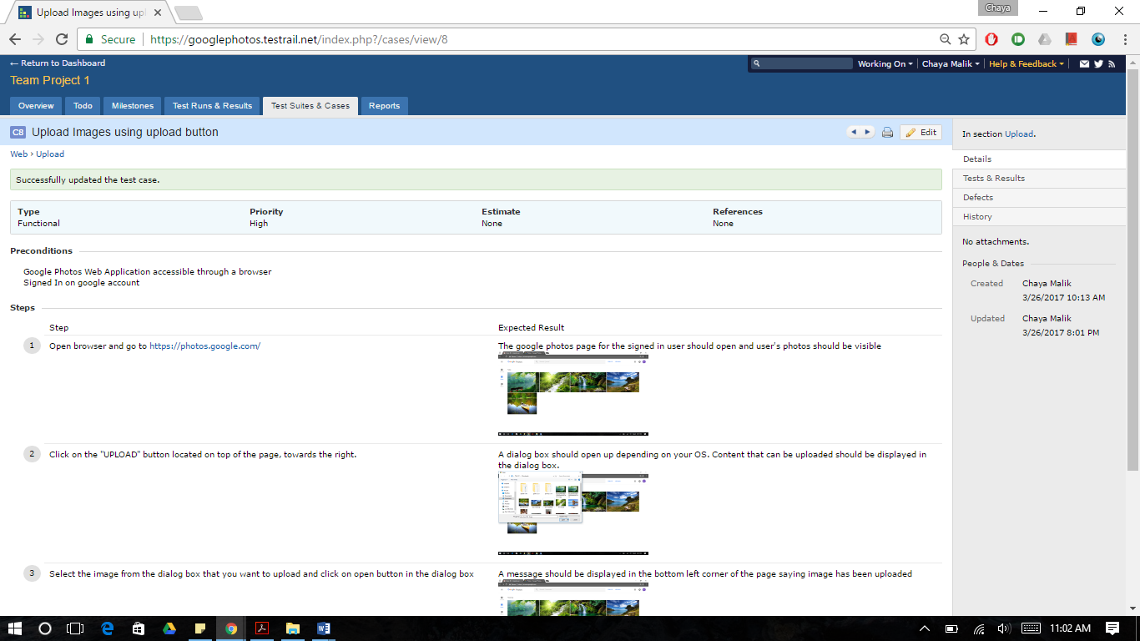

1. Tools used

* Jira
* TestRail
* Quick Time Player
* Google Chrome Developer Tools
* Android Studio